Rapid Elimination of Wound Bed and Periwound Bacterial Fluorescence Using a Novel Chemical Debridement Agent: A Case Report
Maha Khan, BSE¹, Johannes P. Snels MSc^{2,} Alberto Cogo MD^{2,3}, Thomas E. Serena MD⁴
- TCU Anne Marie Burnett School of Medicine, Fort Worth, TX, USA.
- DEBx Medical, Amsterdam, NL.
- Villa Berica, Vicenza, IT
- SerenaGroup, Cambridge, MA, USA
Abstract:
Fluorescence imaging identifies bacteria at levels exceeding the chronic inhibitory bacterial load (CIBL, 10^⁴ CFU/g). Wounds with bacterial levels at or above the critical infection burden level (CIBL) heal poorly. Recent studies have shown that sharp debridement in combination with antiseptics requires 2 to 3 weeks to eliminate wound bed fluorescence and has no effect on periwound fluorescence. Topical Desiccation Agens (TDA) (DEBRICHEM→, Amsterdam, NL) is a novel chemical debridement that removes water from the wound, kills bacteria, and disrupts biofilm. TDA has no adverse effects on intact skin due to its relatively low water content. The significance of periwound fluorescence is unknown; however, clinical experience suggests it is associated with delayed wound healing. This is the case of a 55-year-old diabetic who presented to the wound clinic after undergoing amputation of his right second toe. Physical examination revealed nonviable tissue in the wound bed. There was no cellulitis. Fluorescence imaging revealed intense red bacterial fluorescence in the wound bed and on the periwound skin. TDA was applied to the wound bed and periwound skin for 60 seconds, after which saline was applied and TDA mechanically removed. The single application of TDA completely removed the nonviable tissue, revealing a wound bed with 100% granulation. Post-application fluorescence imaging demonstrated elimination of bacterial fluorescence in the wound bed and periwound skin. This is the first case observation of the eradication of periwound fluorescence, concluding that TDA debrides and reduces bacterial burden in nonhealing wounds and may have a positive effect on periwound bacterial load.
Introduction
Nonhealing wounds are a significant and growing burden to the United States healthcare system, owing to their rising incidence and associated morbidity and mortality. It is estimated that approximately 6.5 million individuals are affected, with annual treatment costs exceeding $25 billion [1,2]. Beyond the economic impact, chronic wounds substantially impair patients’ quality of life through persistent pain, odor, reduced mobility, and social isolation [3]. Distressingly, several studies have reported five-year mortality rates in patients with chronic wounds that approach those observed in common cancers [4]. Given these profound clinical and societal implications, effective strategies for prevention and management remain imperative beginning with the challenge of biofilm.
Biofilms contribute to delayed wound healing. They employ diverse survival strategies that render them resistant to topical antimicrobials and systemic antibiotics. In fact, an incremental increase in bacterial burden has been shown to delay healing by up to 44% for every tenfold increase in bacterial colony-forming unit [5]. Current guidelines on the treatment of biofilms advocate for a multifaceted approach, including sharp debridement, topical antiseptics, and advanced wound care modalities [6]. Biofilm communities exhibit increased tolerance to antiseptic agents compared with acute infections [7], underscoring the need for alternative strategies. Recent multicenter studies have demonstrated that point-of-care fluorescence imaging accurately detects bacteria including biofilm-based organisms [8].
Sharp surgical debridement remains the gold standard for biofilm management, as it disrupts the extracellular polymeric substance (EPS) and renders bacteria more susceptible to antimicrobials [9]. Nonetheless, surgical debridement is limited by rapid biofilm reformation within 24 hours [10], incomplete eradication of biofilm-embedded organisms [11], the risk of bleeding, pain, and challenges in accessing deeper wound tissues where biofilms may reside [12]. Recently, chemical debridement agents have emerged as promising adjuncts, capable of disrupting the biofilm matrix, lowering bacterial load, and promoting healing through effective removal of necrotic tissue and debris [13].
Methane Sulfonic Acid (MSA), developed as a topical desiccation agent (TDA), offers a novel chemical approach to wound debridement. TDA possesses potent hygroscopic and acidic properties, leading to rapid desiccation, protein denaturation, and carbonization of necrotic tissue and biofilm matrices [14]. Within 60 seconds of application, tissues containing necrosis and microorganisms undergo coagulation and precipitate formation, which then separate from the wound bed to yield a clean, granulating surface. Preclinical studies using in vitro biofilm models have demonstrated complete eradication of viable bacterial cells following a 30-second exposure to this topical agent [15]. The low water content in the stratum corneum protects intact skin from the acid’s desiccating action.
This case study reports the therapeutic application of MSA as a chemical debriding agent in a 55-year-old patient with diabetes mellitus, following amputation of the right second toe.
Case Presentation:
A 55-year-old male with a history of uncontrolled diabetes mellitus presented to the outpatient wound care clinic for evaluation shortly post-amputation of the right toe. The patient was referred for ongoing wound care following surgery. Physical examination demonstrated an open amputation site covered with nonviable tissue. There were no signs of cellulitis, such as erythema, warmth, or fluctuance. The periwound skin appeared intact. Point-of-care fluorescence imaging was performed to assess and quantify the bacterial burden in the granulation bed. Imaging demonstrated intense red fluorescence, consistent with high bacterial load. The fluorescence signal also extended into the periwound skin, indicating widespread superficial colonization not apparent on visual inspection by the clinician (Figure 1).
Figure 1: Standard and Fluorescence Imaging on Presentation of the case. In the fluorescence imaging the Green colouring is the signal of high bacterial load.
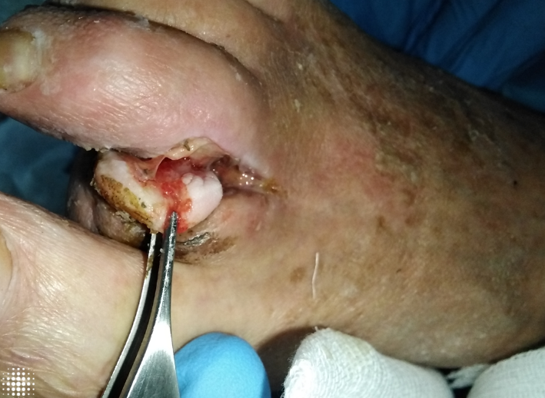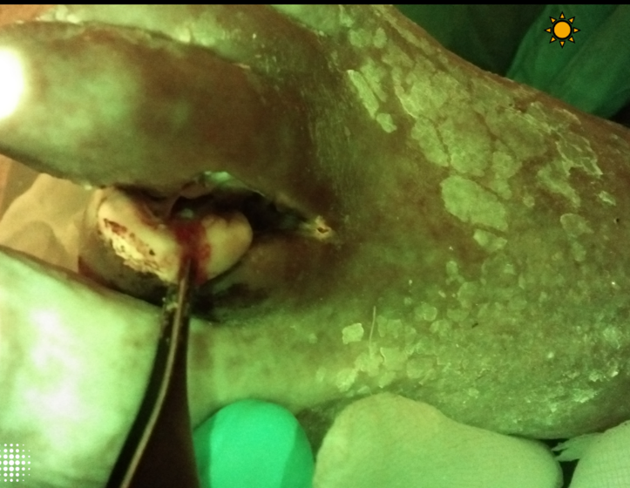
TDA for chemical debridement, was applied directly to the wound bed and periwound tissue for sixty seconds. The agent was then mechanically removed per the manufacturer’s protocol, by usage of ample saline to rinse TDA off to neutralize the desiccation action. This revealed a wound bed with 100% granulation following removal of nonviable tissue. Repeat fluorescence imaging following the single application demonstrated complete resolution of the red fluorescence in both the wound bed and periwound skin (Figure 2). This diagnostic method ensured adequate bacterial clearance. No adverse effects were observed, and the patient tolerated the treatment well. Follow up in one week revealed an improved wound with a fully granulated base (figure 3).
Figure 2 Standard and Fluorescence Imaging of the case Post TDA Application, in the fluorescence image the fluorescence was completely gone
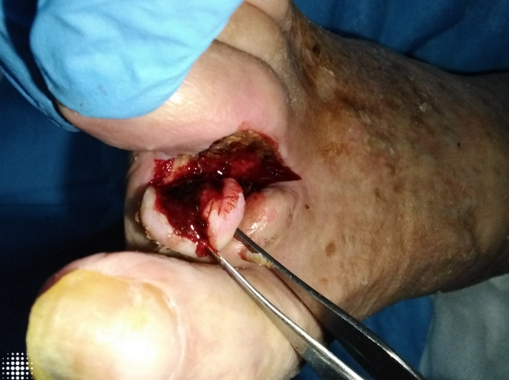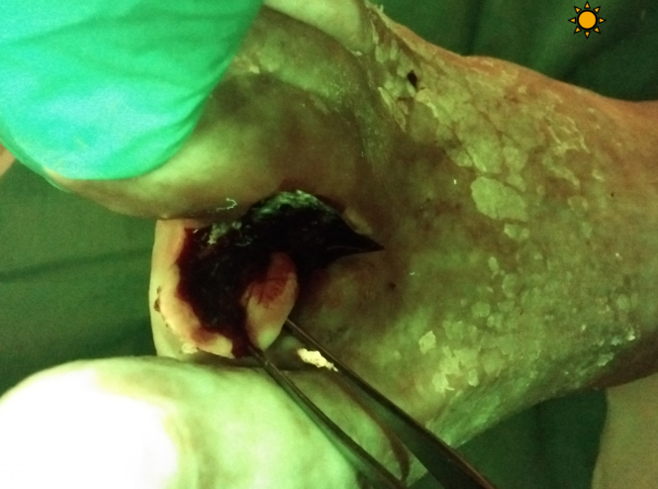
Figure 3 One Week Post MSA Application
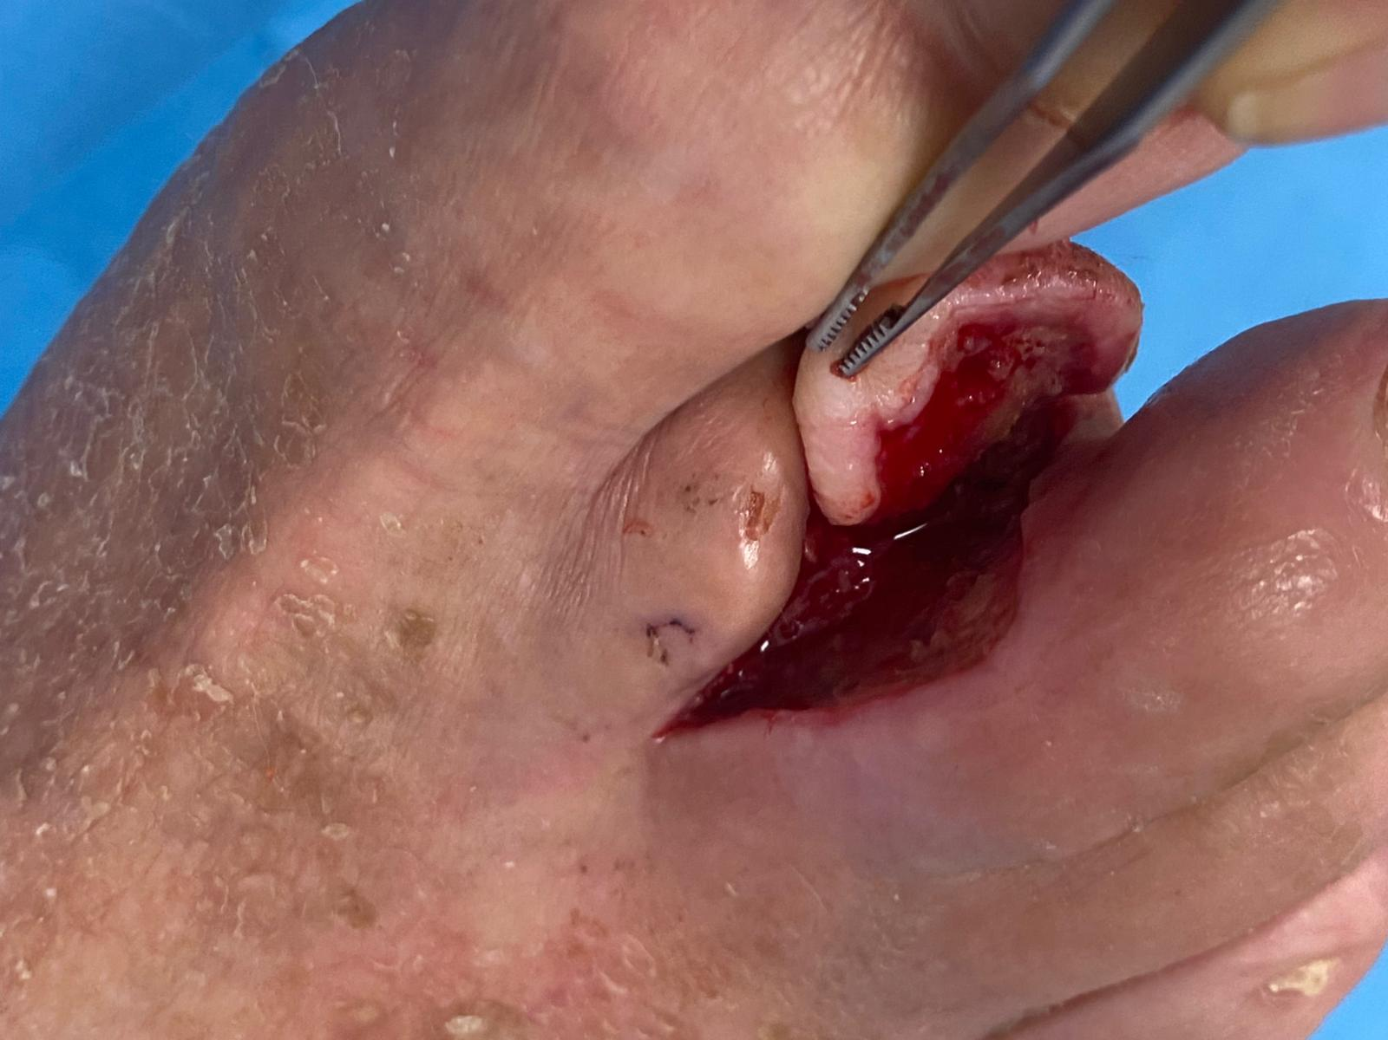
Discussion:
Chronic wounds challenge clinicians and place a heavy burden on healthcare systems worldwide [16]. Persistent bacterial burden and biofilm are major contributors of delayed wound healing [17]. Several studies have demonstrated that bacteria within chronic wounds frequently organize into biofilms, which are difficult to eradicate and contribute to antibiotic resistance. This resistance allows bacteria to persist and release destructive enzymes, further impairing tissue viability and delaying wound closure [18]. Fluorescence imaging detects clinically significant bacteria before the signs and symptoms of infection are evident [8]. Early identification of elevated levels of bacteria and biofilm allows the clinician to use topical agents to eliminate bacteria before systemic agents are required.
Debridement remains the cornerstone of wound management. Several methods are described in the literature and used in clinical practice, including sharp surgical, mechanical, autolytic, and enzymatic. More recently, TDA, a chemical debridement agent, was introduced as an alternative to traditional debridement techniques. TDA works by removal of biofilm, devitalized tissue and necrosis rapidly [14]. The primary action of TDA is its ability to readily absorb water from its surroundings, such as planktonic microbial cells, which leads to the destruction of the bacterial cell membrane lipid bilayer [15]. TDA may have advantages over other types of debridement. Sharp debridement requires surgical skills, anesthesia and can lead to bleeding. TDA, in contrast, is easy to apply and in the author’s, opinion is mildly hemostatic. Autolytic and enzymatic debridement agents require multiple applications to show effect whereas TDA can achieve complete debridement following a single 60 second application. Mechanical debridement is not effective in eradicating biofilm like TDA. It is clear that TDA will be a disruptive technology in the wound care space replacing many of the traditional debridement techniques [19,20,21].
Despite these promising attributes, clinical evidence supporting the use of TDA in wound care is limited. Preclinical studies have demonstrated the agent’s efficacy against Pseudomonas aeruginosa and Staphylococcus aureus biofilms in vitro, reporting complete eradication of viable bacterial cells after a 30-second exposure [22]. To date, clinical application of TDA for chronic wounds has not been widely documented, making this report one of the first to describe its real-world utility in an outpatient setting validated with fluorescence imaging. Several clinical trials are underway across the globe.
Although the findings presented here suggest that TDA may be a rapid, non-invasive, and effective option for biofilm and necrotic tissue removal, the results must be interpreted with caution. As this is a single case report, the findings cannot be generalized to broader patient populations or diverse wound types. Larger, prospective clinical studies are ongoing to confirm its safety, efficacy, and role within the armamentarium of wound debridement strategies.
Conclusion
This single case study suggests that TDA may play a role in the elimination of biofilm and debridement of chronic wounds for a rapid usage of just one sixty seconds application where the fluorescence imaging can validate its immediate effect.

References
- Falanga V, Isseroff RR, Soulika AM, Romanelli M, Margolis D, Kapp S, Granick M, Harding K. Chronic wounds. Nat Rev Dis Primers. 2022 Jul 21;8(1):50. doi: 10.1038/s41572-022-00377-3. PMID: 35864102; PMCID: PMC10352385.
- Sen CK, Gordillo GM, Roy S, Kirsner R, Lambert L, Hunt TK, Gottrup F, Gurtner GC, Longaker MT. Human skin wounds: a major and snowballing threat to public health and the economy. Wound Repair Regen. 2009 Nov-Dec;17(6):763-71. doi: 10.1111/j.1524-475X.2009.00543.x. PMID: 19903300; PMCID: PMC2810192.
- Vecin NM, Kirsner RS. Skin substitutes as treatment for chronic wounds: current and future directions. Front Med (Lausanne). 2023 Aug 29;10:1154567. doi: 10.3389/fmed.2023.1154567. PMID: 37711741; PMCID: PMC10498286.
- Vecin NM, Kirsner RS. Skin substitutes as treatment for chronic wounds: current and future directions. Front Med (Lausanne). 2023 Aug 29;10:1154567. doi: 10.3389/fmed.2023.1154567. PMID: 37711741; PMCID: PMC10498286.
- Thaarup IC, Iversen AKS, Lichtenberg M, Bjarnsholt T, Jakobsen TH. Biofilm Survival Strategies in Chronic Wounds. Microorganisms. 2022 Apr 5;10(4):775. doi: 10.3390/microorganisms10040775. PMID: 35456825; PMCID: PMC9025119.
- Liu Y, Long S, Wang H, Wang Y. Biofilm therapy for chronic wounds. Int Wound J. 2024 Feb;21(2):e14667. doi: 10.1111/iwj.14667. PMID: 38339793; PMCID: PMC10858329.
- Hurlow J, Wolcott RD, Bowler PG. Clinical management of chronic wound infections: The battle against biofilm. Wound Repair Regen. 2025 Jan-Feb;33(1):e13241. doi: 10.1111/wrr.13241. Epub 2024 Nov 27. PMID: 39600232.
- Le L, Baer M, Briggs P, Bullock N, Cole W, DiMarco D, Hamil R, Harrell K, Kasper M, Li W, Patel K, Sabo M, Thibodeaux K, Serena TE. Diagnostic Accuracy of Point-of-Care Fluorescence Imaging for the Detection of Bacterial Burden in Wounds: Results from the 350-Patient Fluorescence Imaging Assessment and Guidance Trial. Adv Wound Care (New Rochelle). 2021 Mar;10(3):123-136. doi: 10.1089/wound.2020.1272. Epub 2020 Sep 25. PMID: 32870774; PMCID: PMC7876364.
- Sen CK, Roy S, Mathew-Steiner SS, Gordillo GM. Biofilm Management in Wound Care. Plast Reconstr Surg. 2021 Aug 1;148(2):275e-288e. doi: 10.1097/PRS.0000000000008142. PMID: 34398099; PMCID: PMC8439557.
- Liu Y, Long S, Wang H, Wang Y. Biofilm therapy for chronic wounds. Int Wound J. 2024 Feb;21(2):e14667. doi: 10.1111/iwj.14667. PMID: 38339793; PMCID: PMC10858329.
- Ning P, Liu Y, Kang J, Cao H, Zhang J. Comparison of healing effectiveness of different debridement approaches for diabetic foot ulcers: a network meta-analysis of randomized controlled trials. Front Public Health. 2023 Dec 11;11:1271706. doi: 10.3389/fpubh.2023.1271706. PMID: 38146472; PMCID: PMC10749485.
- Manna B, Nahirniak P, Morrison CA. Wound Debridement. [Updated 2023 Apr 19]. In: StatPearls [Internet]. Treasure Island (FL): StatPearls Publishing; 2025 Jan-. Available from: https://www.ncbi.nlm.nih.gov/books/NBK507882/
- Nowak M, Mehrholz D, Barańska-Rybak W, Nowicki RJ. Wound debridement products and techniques: clinical examples and literature review. Postepy Dermatol Alergol. 2022 Jun;39(3):479-490. doi: 10.5114/ada.2022.117572. Epub 2022 Jul 14. PMID: 35950126; PMCID: PMC9326937.
- Cogo A, Bignozzi AC, Hermans MH, Quint BJ, Snels JP, Schultz G. A desiccation compound as a biofilm- and necrosis-removing agent: a case series. J Wound Care. 2022 Oct 2;31(10):816-822. doi: 10.12968/jowc.2022.31.10.816. PMID: 36240800.
- Schwarzer S, Radzieta M, Jensen SO, Malone M. Efficacy of a Topical Wound Agent Methanesulfonic Acid and Dimethylsulfoxide on In Vitro Biofilms. Int J Mol Sci. 2021 Aug 31;22(17):9471. doi: 10.3390/ijms22179471. PMID: 34502378; PMCID: PMC8431709.
- Frykberg RG, Banks J. Challenges in the Treatment of Chronic Wounds. Adv Wound Care (New Rochelle). 2015 Sep 1;4(9):560-582. doi: 10.1089/wound.2015.0635. PMID: 26339534; PMCID: PMC4528992.
- Rahim K, Saleha S, Zhu X, Huo L, Basit A, Franco OL. Bacterial Contribution in Chronicity of Wounds. Microb Ecol. 2017 Apr;73(3):710-721. doi: 10.1007/s00248-016-0867-9. Epub 2016 Oct 14. PMID: 27742997.
- Maheswary T, Nurul AA, Fauzi MB. The Insights of Microbes' Roles in Wound Healing: A Comprehensive Review. Pharmaceutics. 2021 Jun 29;13(7):981. doi: 10.3390/pharmaceutics13070981. PMID: 34209654; PMCID: PMC8308956.
- Snels JP, Cogo A, Reitano R, Grigolo C, Quint BJ, Bignozzi CA. Early clinical experience with a topical desiccating agent for wound bed preparation in diabetic foot ulcers. J Wound Care. 2025;34(9):704-706. doi:10.12968/jowc.2025.0240
- Cogo A, Bignozzi AC, Hermans MH, Quint BJ, Snels JP, Schultz G. A desiccation compound as a biofilm- and necrosis-removing agent: a case series. J Wound Care. 2022;31(10):816-822. doi:10.12968/jowc.2022.31.10.816
- Shabes P, Garabet W, Tilhein S, Schelzig H, Rembe JD. Pain perception and management during chemical debridement with a topical desiccating agent: a case-series analysis. J Wound Care. 2025;34(9):747-752. doi:10.12968/jowc.2025.0136
- Binnemans K, Jones PT. Methanesulfonic acid (MSA) in clean processes and applications: a tutorial review. Green Chem. 2024 Jun 27;26(15):8583-8614. doi: 10.1039/d4gc02031f. PMID: 39081497; PMCID: PMC11284624.

